LAPTOP DAMAGE FORM
Name: _________________________ SSIS ID #: _______________

Signature: ________________________________
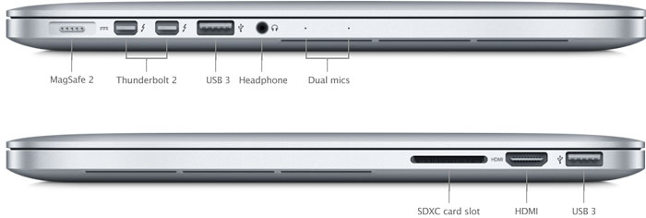

Key: D = Dent M = Missing S = Scratch

Details of damage

How did the damage happen

